**VISVESVARAYA TECHNOLOGICAL UNIVERSITY**

**“Jnana Sangama”, Belgaum -590014, Karnataka.**



**PROJECT WORK-2 REPORT**

**On**

**“Conference Paper submission ”**

***Submitted by***

**S SHREE LAKSHMI (1BM19CS136)**

**SAKSHI ROY (1BM19CS140)**

**SHARAN S PAI (1BM19CS146)**

**SHANSHANK SHARMA (1BM19CS147)**

***Under the Guidance of***

|  |
| --- |
| **Mr. Vikranth BM**  **Ass**istant Professor |

***in partial fulfillment for the award of the degree of***

**BACHELOR OF ENGINEERING**

***in***

**COMPUTER SCIENCE AND ENGINEERING**



**B.M.S. COLLEGE OF ENGINEERING**

**(Autonomous Institution under VTU)**

**BENGALURU-560019**

**JUNE 2021**

**B. M. S. College of Engineering,**

**Bull Temple Road, Bangalore 560019**

(Affiliated To Visvesvaraya Technological University, Belgaum)

**Department of Computer Science and Engineering**



**CERTIFICATE**

This is to certify that the project work entitled **“Conference Paper Submission”** carried out by **S SHREE LAKSHMI (1BM19CS136), SAKSHI ROY (1BM19CS140), SHARAN S PAI (1BM19CS146), SHASHANK SHARMA (1BM19CS147)** who are bonafide students of **B. M. S. College of Engineering.** It is in partial fulfillment for the award of **Bachelor of Engineering in Computer Science and Engineering** of the Visveswaraiah Technological University, Belgaum during the year 2021. The project report has been approved as it satisfies the academic requirements in respect of **Project Work-2(19CS4PWPW2)** work prescribed for the said degree.

Signature of the Guide                 Signature of the HOD

Prof. Vikranth BM Dr. Umadevi V.

Assistant Professor Prof & Head of Dept of CSE

BMSCE, Bengaluru BMSCE, Bengaluru

External Viva

Name of the Examiner                                                               Signature with date

**B.M.S. College of EngineerinG**

**DEPARTMENT OF COMPUTER SCIENCE AND ENGINEERING**



**DECALARATION**

We,**SHARAN S PAI(1BM19CS146), SAKSHI ROY(1BM19CS140), S SHREE LAKSHMI(1BM19CS136), SHASHANK SHARMA(1BM19CS147)** students of 4th Semester, B.E, Department of Computer Science and Engineering, BMS College of Engineering, Bangalore, hereby declare that, this Project Work-2 entitled **"Conference Paper Submission"** has been carried out by us under the guidance of Prof. Vikranth BM, Assistant Professor, Department of CSE, BMS College of Engineering, Bangalore during the academic semester February-June 2021.

We also declare that to the best of our knowledge and belief, the development reported here is not from part of any other report by any other students.

Signature

**S SHREE LAKSHMI(1BM19CS136),**

**SAKSHI ROY(1BM19CS140),**

**SHARAN S PAI(1BM19CS146),**

**SHASHANK SHARMA(1BM19CS147)**

**TABLE OF CONTENTS**

|  |  |  |
| --- | --- | --- |
| **Serial**  **No.** | **TITLE** | **PAGE NO.** |
| 1 | **Introduction** | 1 |
| 1.1 | Overview | 1 |
| 1.2 | Motivation | 1 |
| 2 | **Software Requirement Specification** | 2 |
| 2.1 | Hardware Requirements | 2 |
| 2.2 | Software Requirements | 2 |
| 3 | **ER diagram of the project** | 3 |
| 4 | **Schema of project** | 4 |
| 5 | **User Interface Design** | 5 |
| 5.1 | Admin | 5 |
| 5.2 | User | 8 |
| 5.3 | Reviewer | 13 |
| 6. | **Database** | 16 |
|  | **Reference** | 20 |

**INTRODUCTION**

* 1. **Overview**

Taking part in a conference provides an opportunity to meet like minded people and go through the work of people who share a common discipline. Through our website students and faculties can take part in various conferences and widen their horizon in their respective field.

Our website allows students/faculties to get information about the recent event, submit their papers as well as receive message from the reviewer on rejection of the paper.

The admin is allowed to provide information about the recent conference as well as register the reviewer and the reviewer can go through the submissions to approve or reject their respective works.

* 1. **Motivation**

Conference papers can be an effective way to try out new ideas, introduce your work to colleagues, and hone your research questions. Presenting at a **conference is** a great opportunity for gaining valuable feedback from a community of scholars and for increasing your professional stature in your field.

A conference paper is a written document that outlines your oral presentation at a conference. These papers cover the details of the presentations for attendees to review in situations when the attendee was not able to hear the oral presentation.

If you need faster feedback regarding the latest scientific innovations, the conference paper ha**s** more value.

**SOFTWARE REQUIREMENTS**

**2.1 Hardware Requirements:**

* A PC with the following or greater specifications:
  + Intel Core i3 ,
  + 4 GB RAM
  + 500 GB Hard Drive
* A stable internet connection (2Mbps +)

**2.2 Software Requirements:**

* Operating system : Windows
* Front end technologies are : HTML, CSS, JavaScript
* IDE : VS Code
* Back end requirement : PHP
* Server : XAMPP server

**3. ER DIAGRAM OF THE PROJECT**

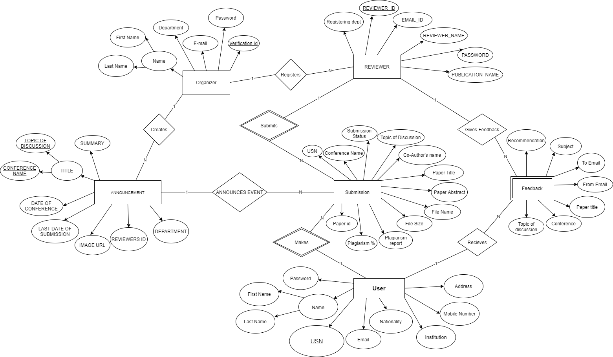

**4. SCHEMA OF THE PROJECT**

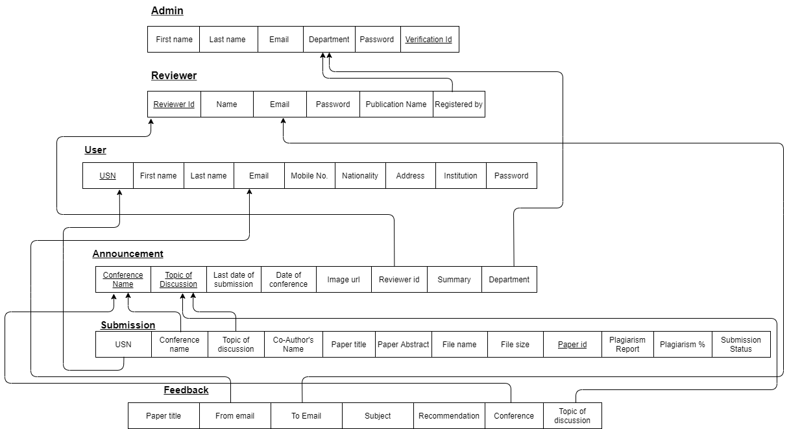

**USER INTERFACE DESIGN**

1. **Login Portal**

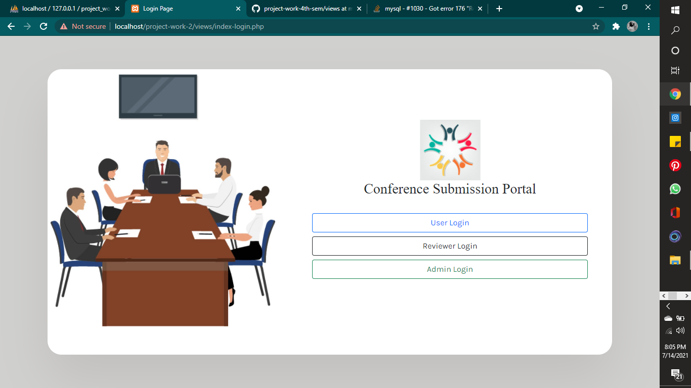

1. **Admin**

**1.1 Admin Login**

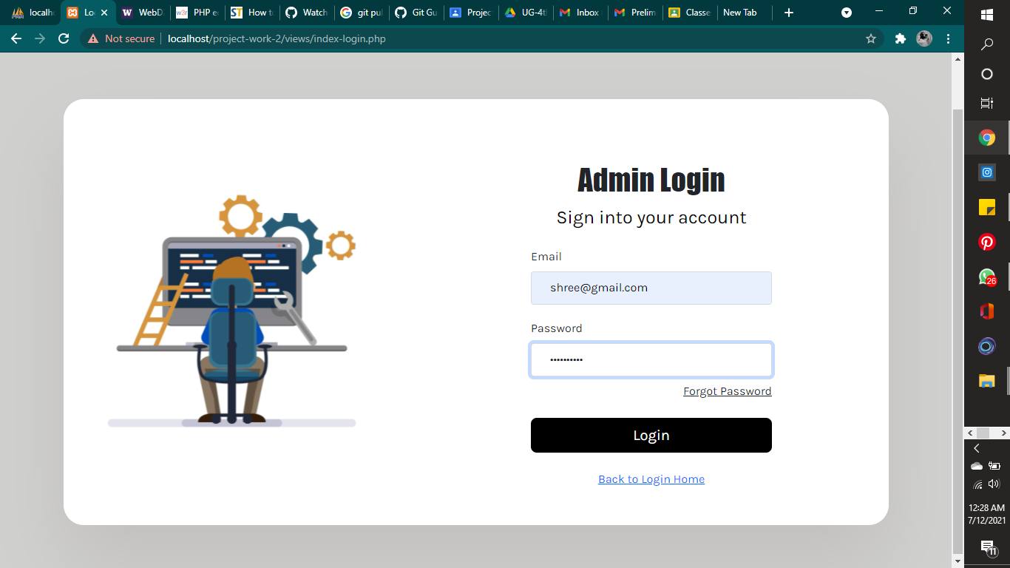

**1.2Admin home page**

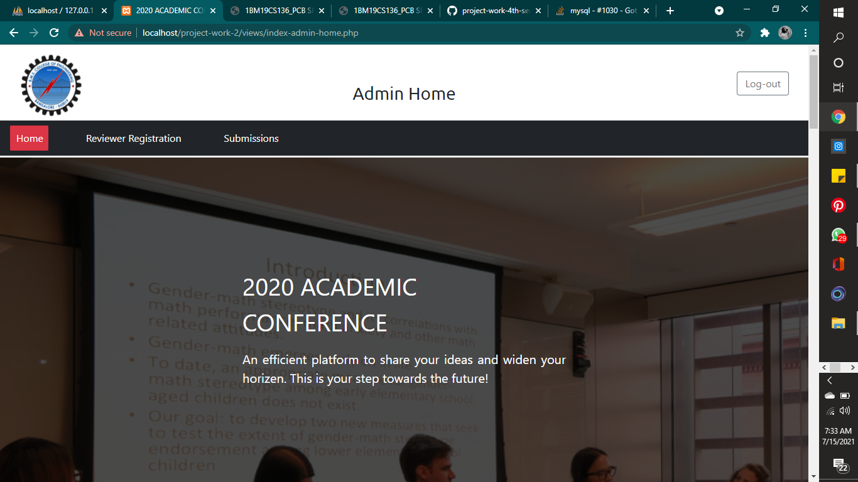

**1.2.1News and announcement**

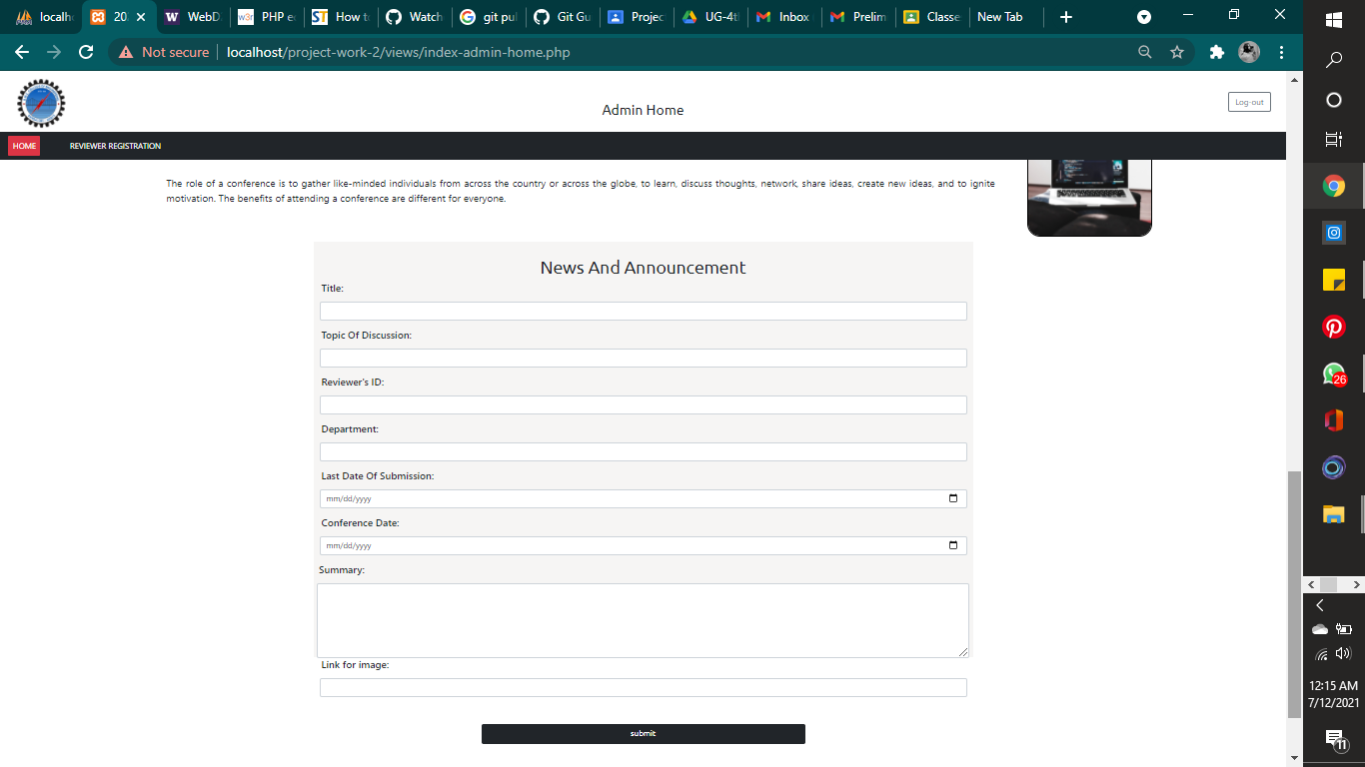

After submitting,

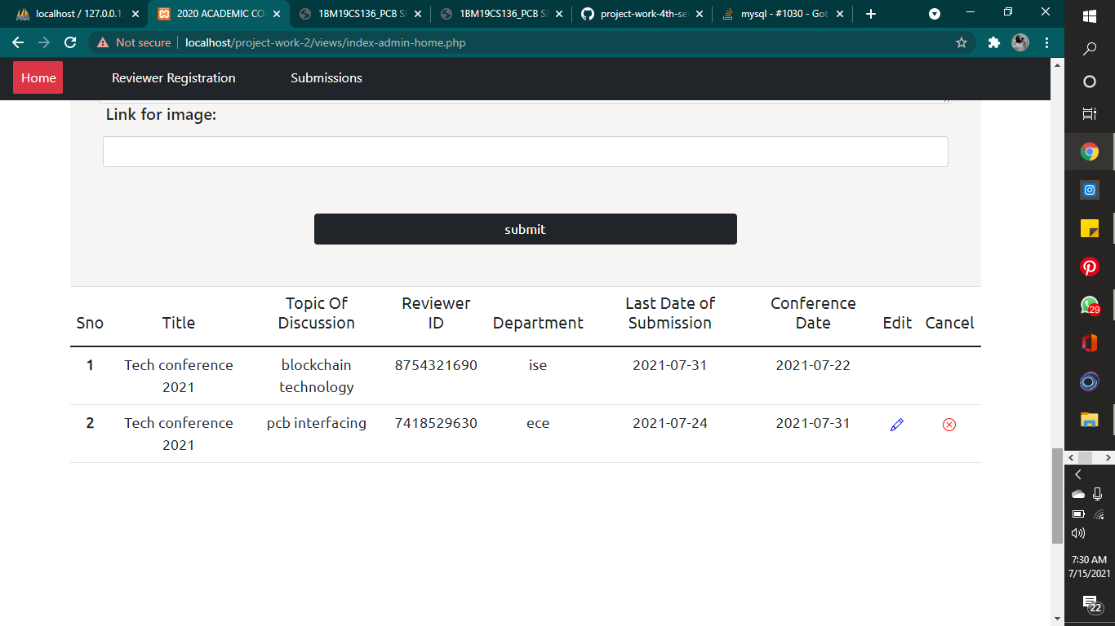

The admin will be able to provide information about any upcoming conferences. Details such as title, topic of discussion , reviewer’s ID, department, last date of submission, conference date and summary will have to be provided by the admin.

This will be reflected at the home page of the user.

**1.3 Admin_reviewer**

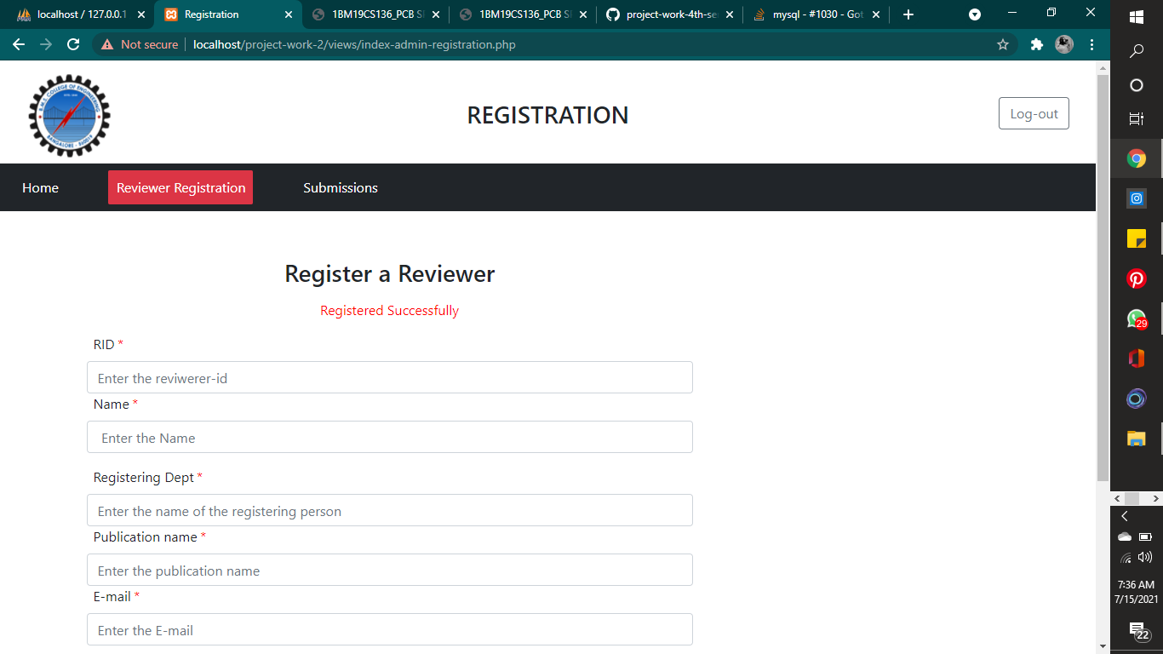

This page is for admin to register the Reviewer for respective conferences

**1.4 Submissions**

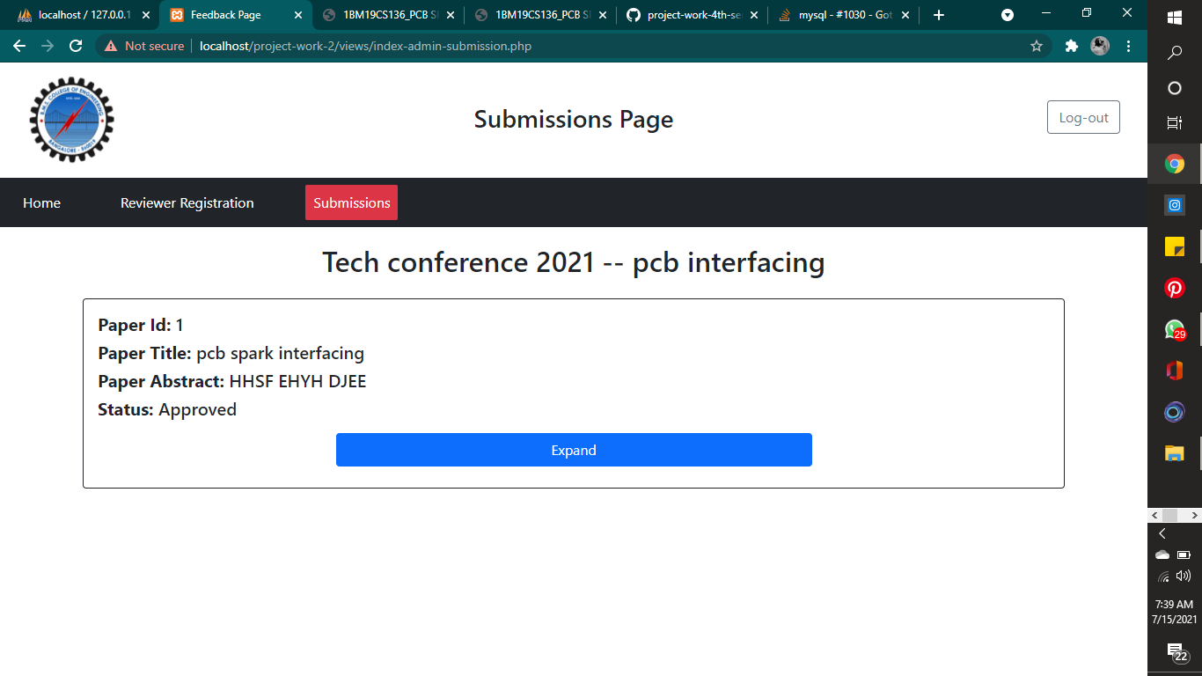

Here the admin will be able to see the all the papers that has been approved by the respective reviewer in charge for the particular conference.

1. **User**

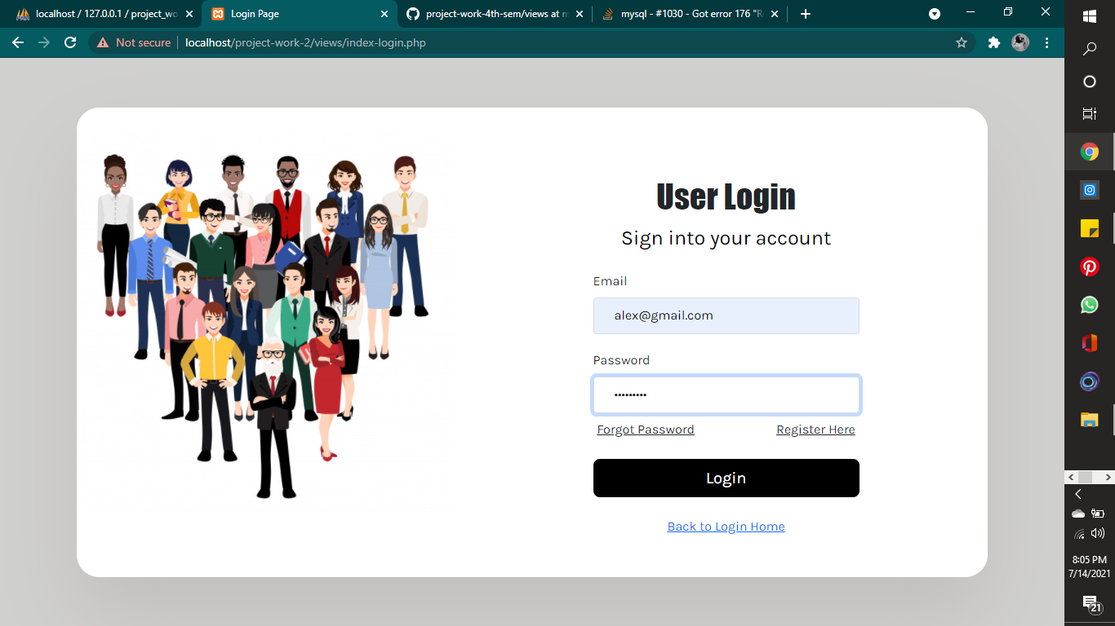

* 1. **Home**

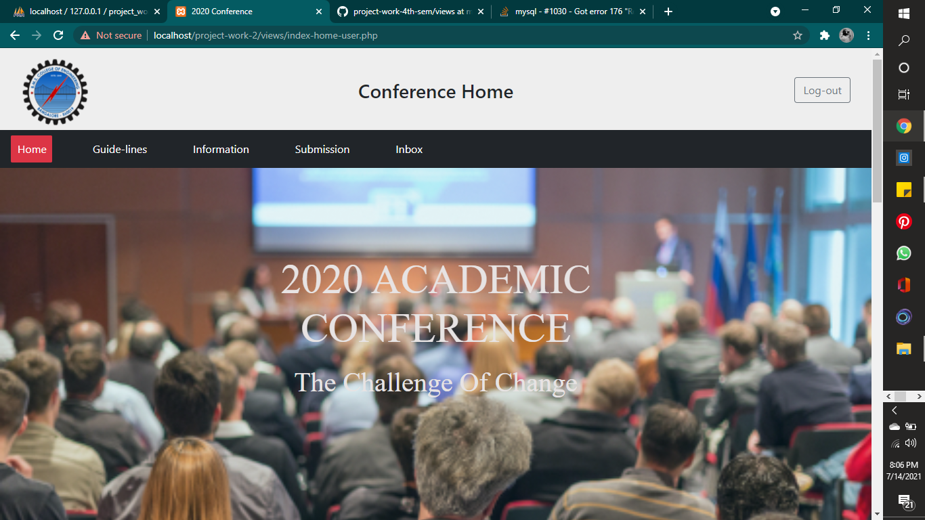

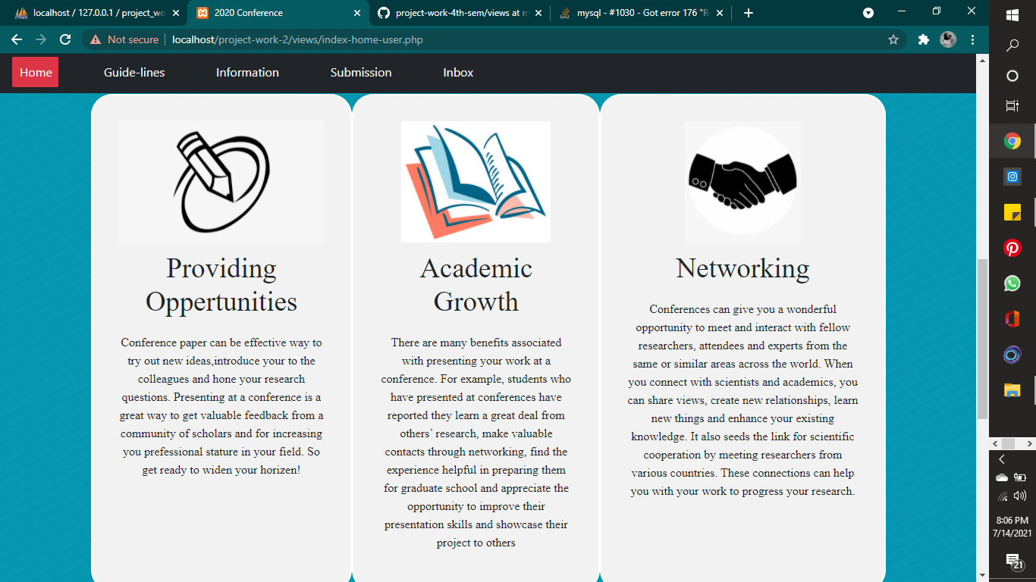

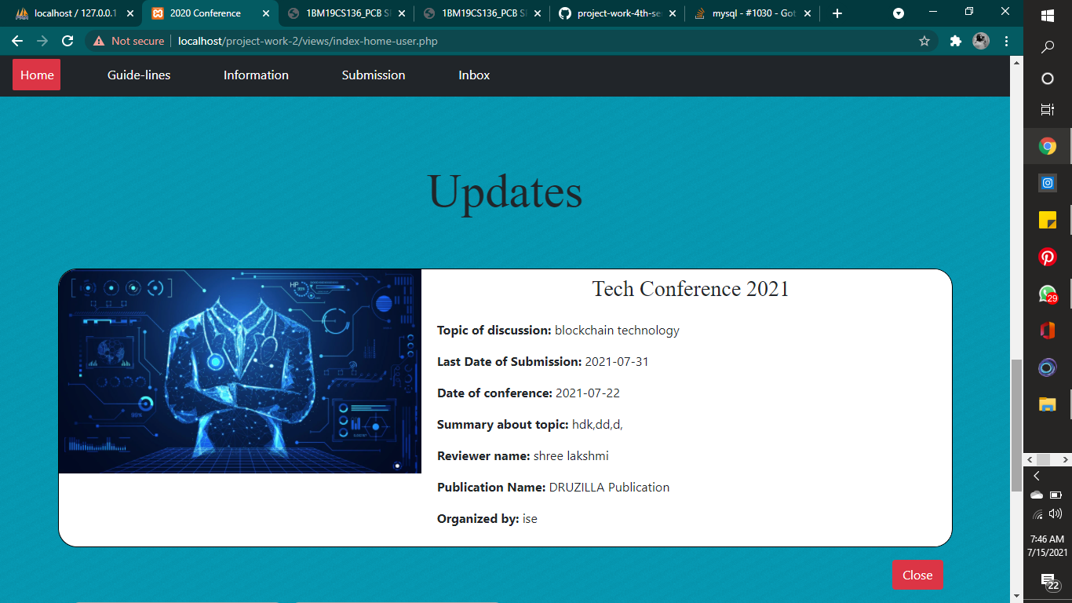

In the home page of the user, the upcoming events will be displayed at the update session.

* 1. **Guidelines**

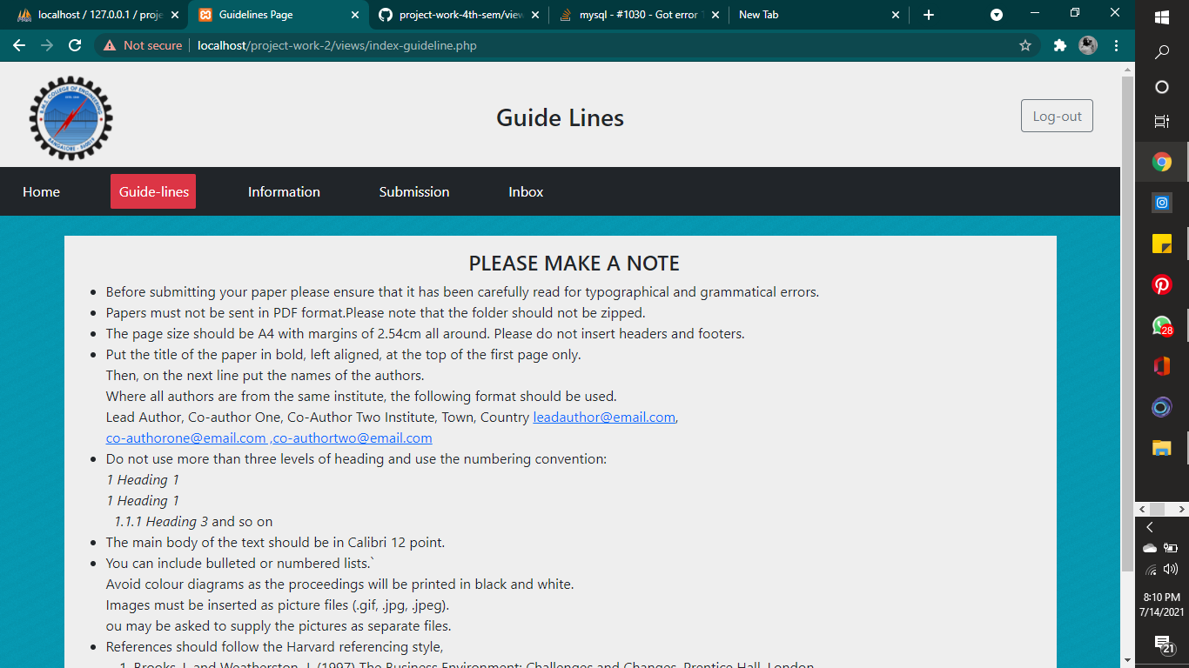

**2.4 Information**

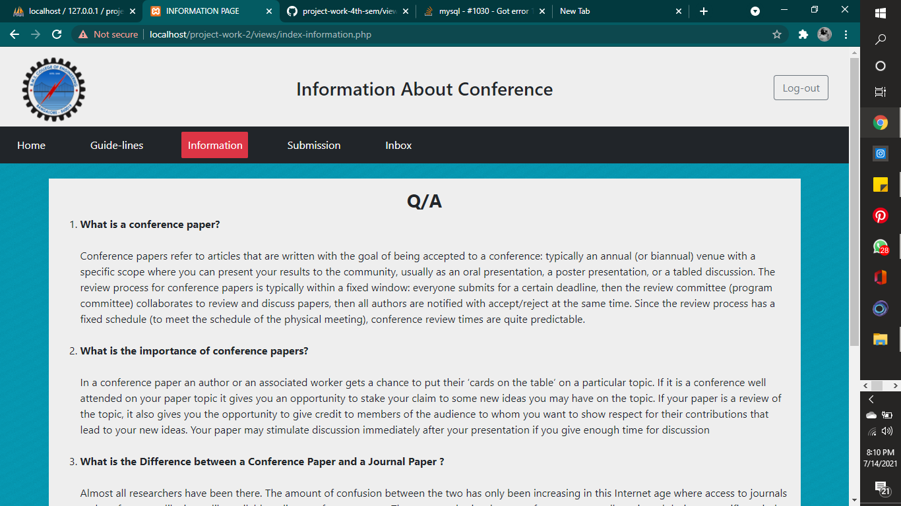

2.5 Submission

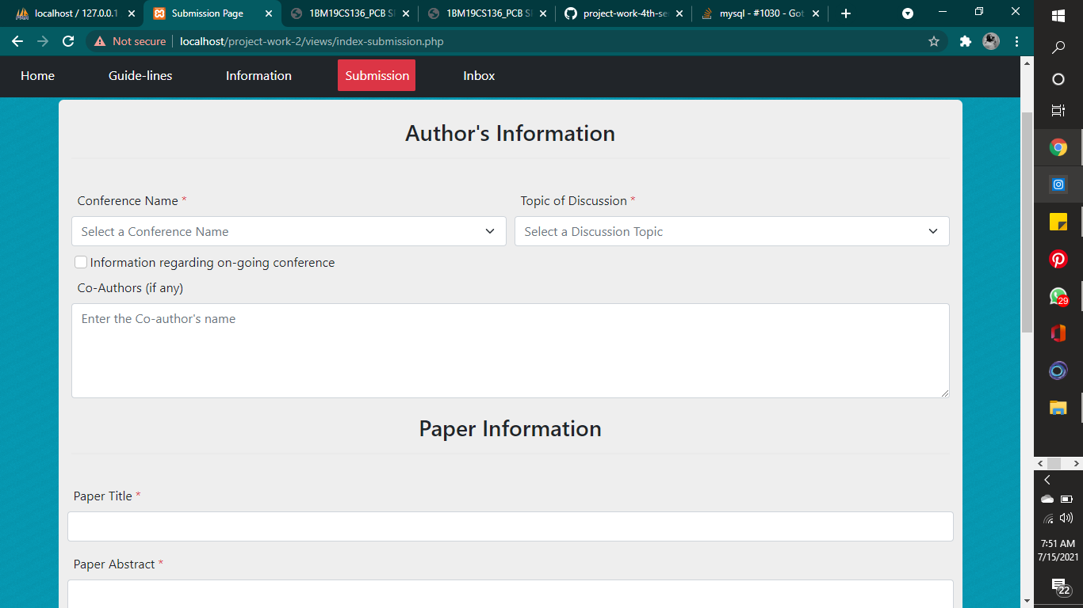

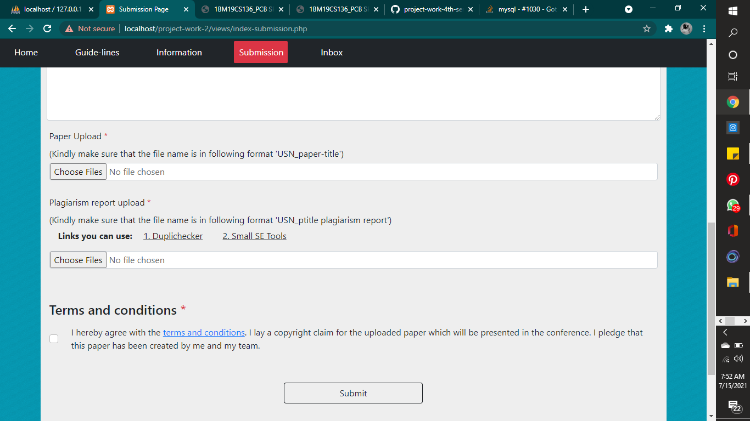

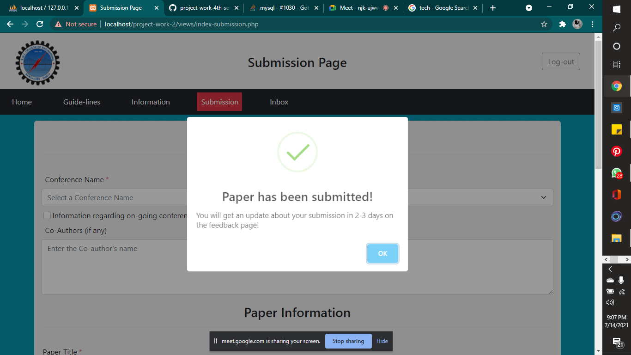

The user is expected to follow certain guidelines regarding the format before submitting. If the user fails to do so, it wont be submitted. Note that Plagiarism links have been provided for the user.

2.6 Inbox

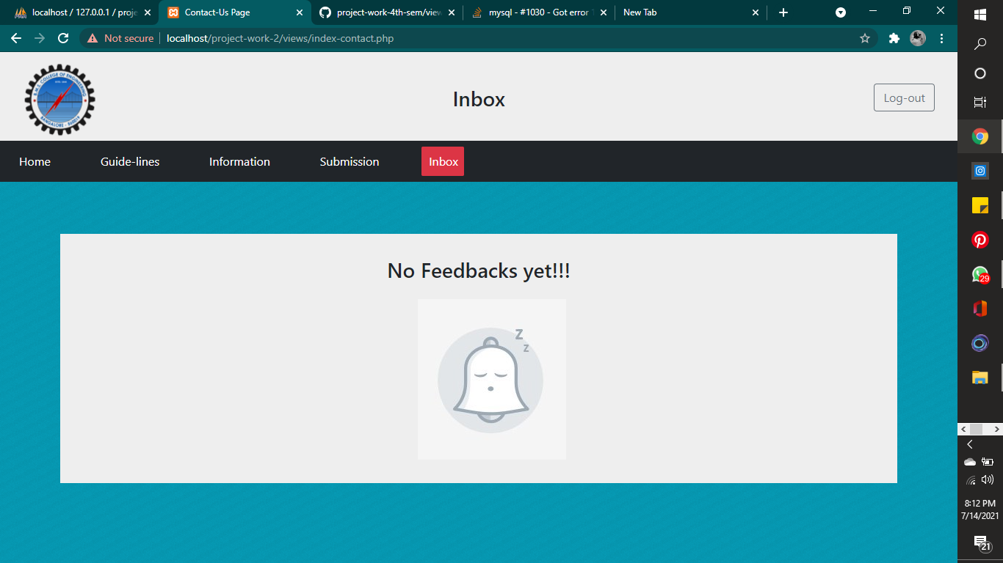

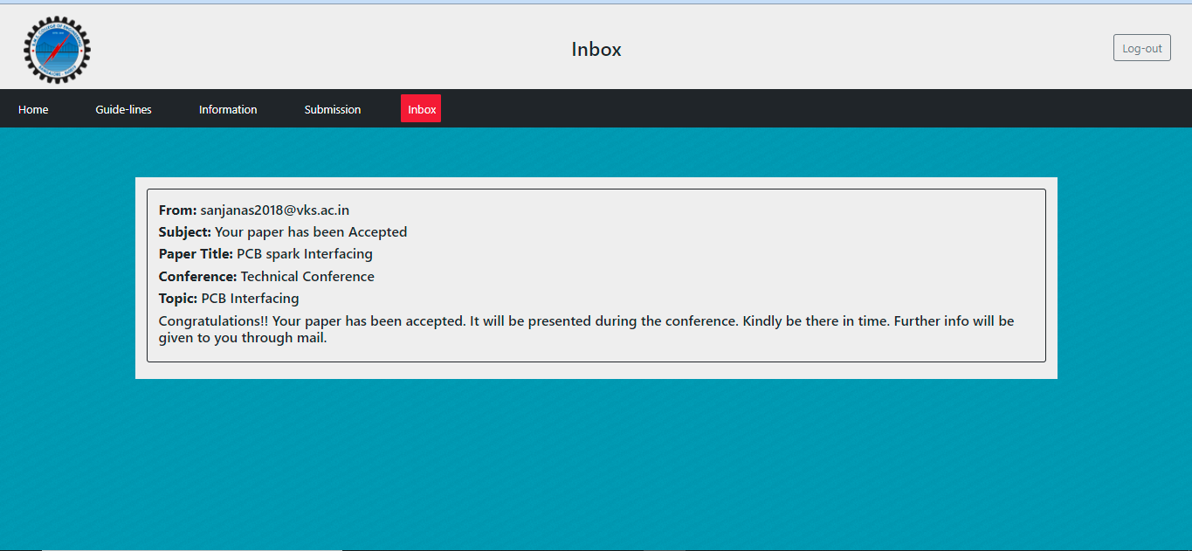

1. **Reviewer**

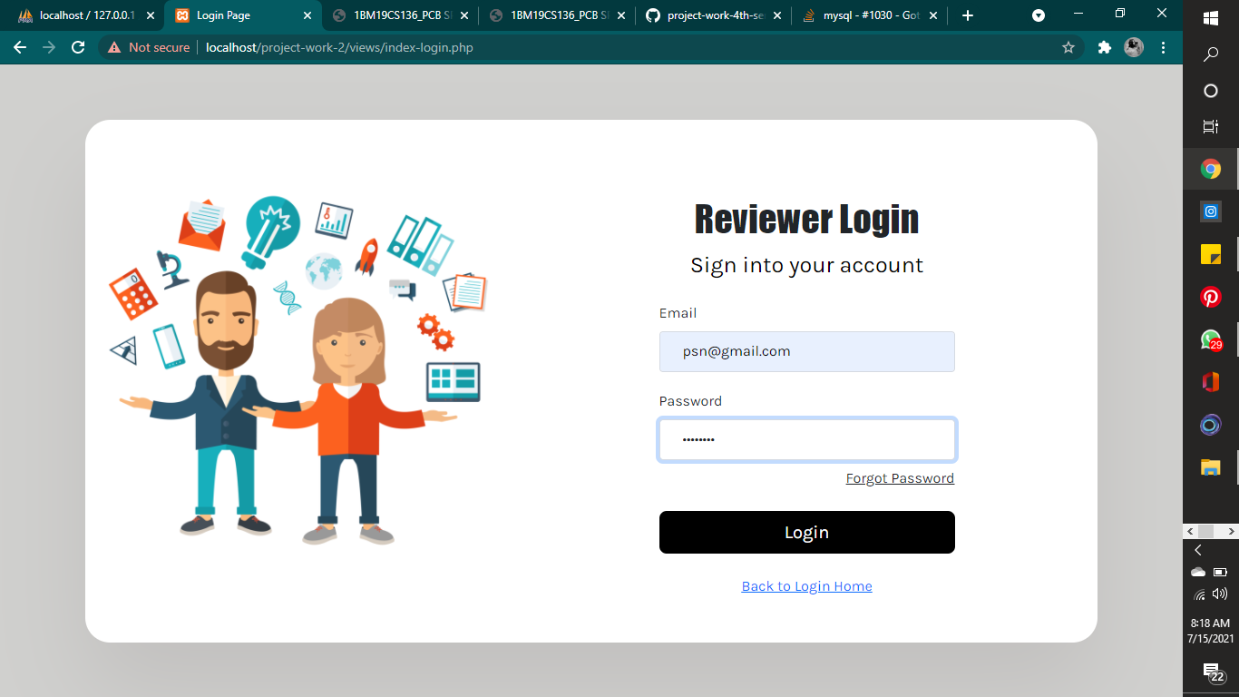

* 1. **Home**

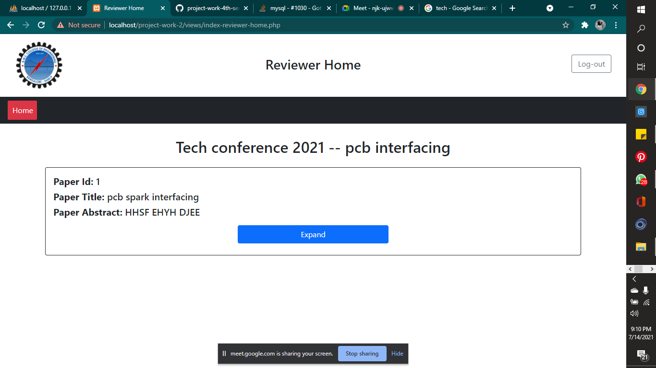

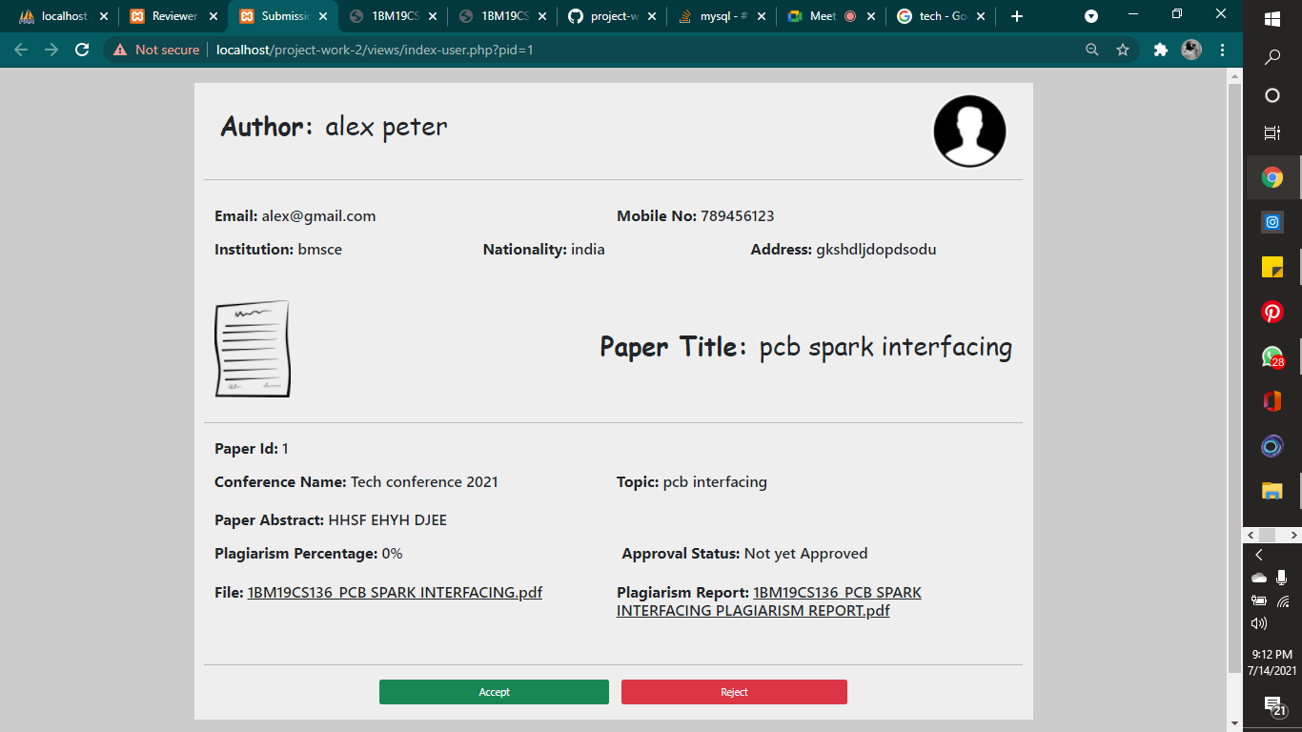

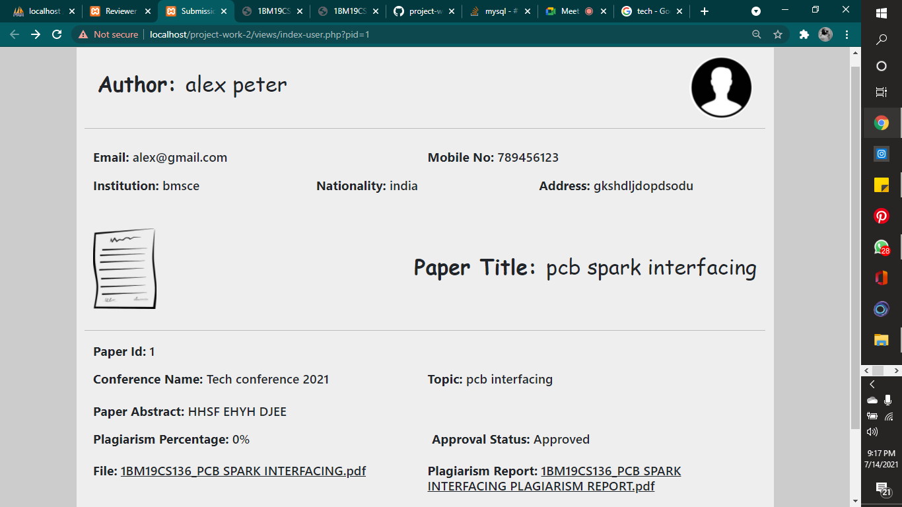

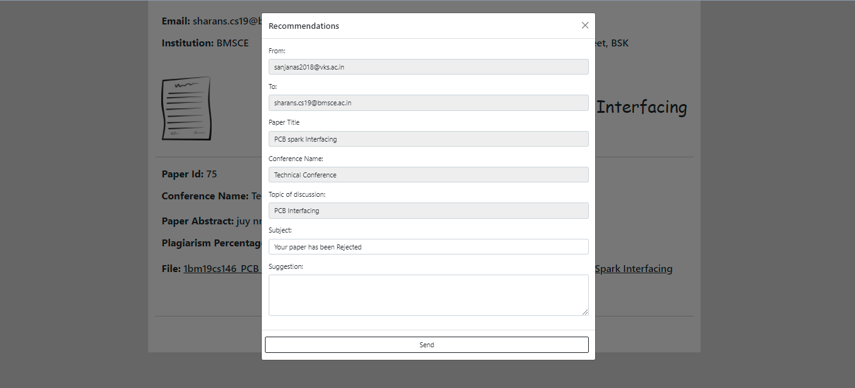

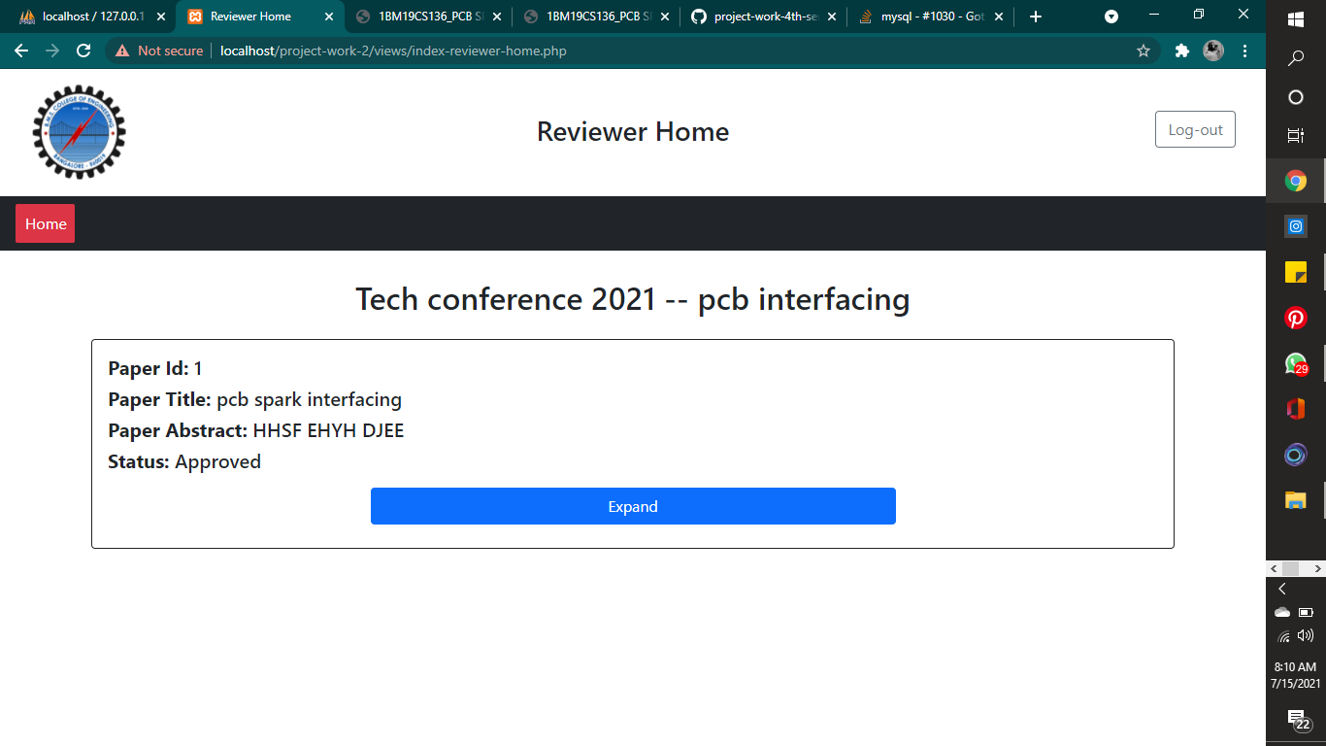

The reviewer will be able to see the number of submissions in the home page. When he clicks on the particular submission , it leads to new tab where all the information about the submission will be mentioned. The reviewer on clicking the file link can download the file and the plagiarism report.

Hence it’s upto the reviewer to either accept or reject.

On accepting , it’ll be approved and on rejecting, it’ll pop up with new form to reason out why it was rejected. This rejection along with reason will be reflected on the user inbox.

**Database:**

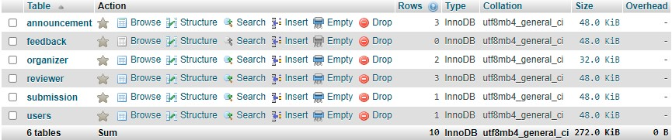

**Table Design:**

**Organizer Table:**

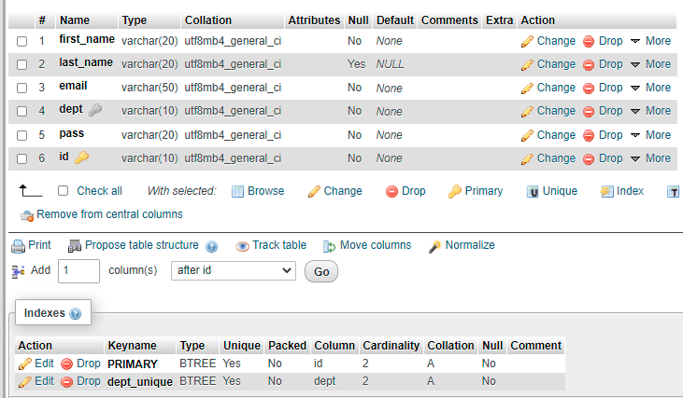

**Reviewer Table:**

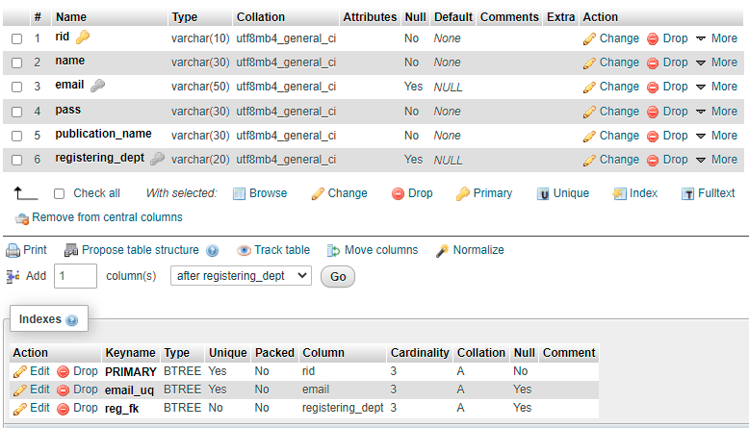

**User Table:**

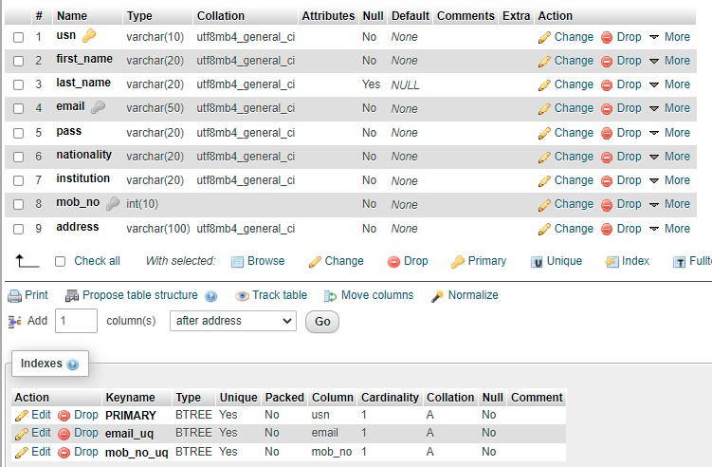

**Announcement table:**

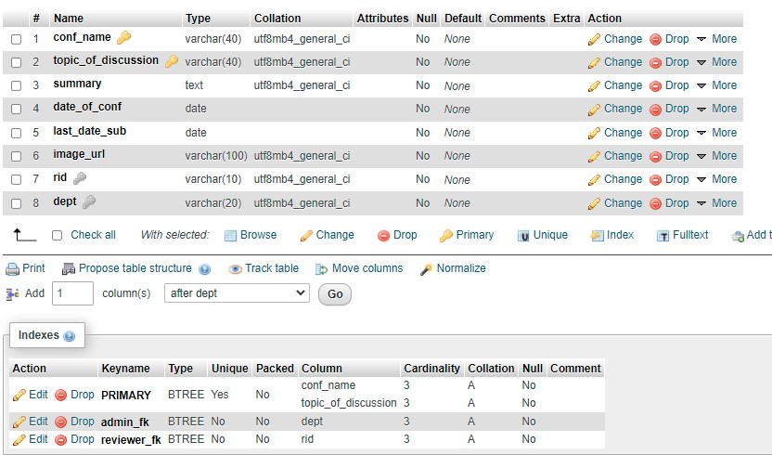

**Submission table:**

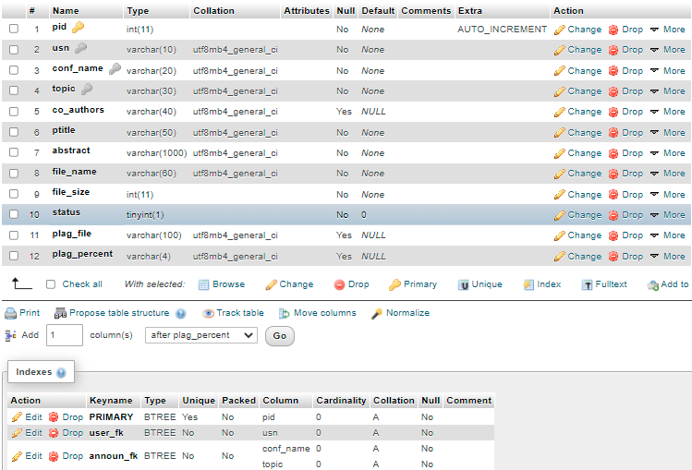

**Feedback table:**

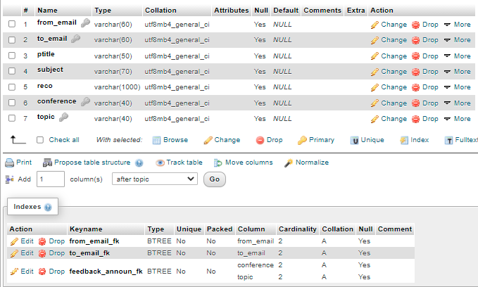

**REFERENCES:**

**Please provide all the website links you used as reference to build the project**

* [**https://www.youtube.com/playlist?list=PLillGF-Rfqbap2IB6ZS4BBBcYPagAjpjn**](https://www.youtube.com/playlist?list=PLillGF-Rfqbap2IB6ZS4BBBcYPagAjpjn)
* [**https://www.w3resource.com/php/php-home.php**](https://www.w3resource.com/php/php-home.php)
* [**https://www.tutorialspoint.com/php/index.htm**](https://www.tutorialspoint.com/php/index.htm)
* **Fundamental of database systems**

**7th edition by Ramez Elmasri and Shamkant B. Navathe**

**SOURCE CODE LINK:**

<https://github.com/sharan-pai-bmsce/project-work-4th-sem>